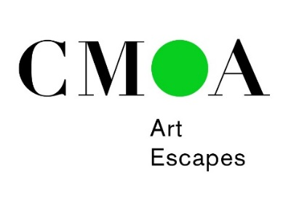

New York with Nannette: November 22–24, 2019
Tentative Itinerary

Friday, November 22: The highlight of our visit will be a stop at the Brooklyn Museum of Art for a curator’s tour of Pierre Cardin: Future Fashion. The exhibition traces the legendary career of one of the fashion world’s most innovative designers, one whose futuristic designs and trailblazing efforts to democratize high fashion for the masses pushed the boundaries of the industry for more than seven decades. The retrospective features over 170 objects that date from the 1950s to the present, including haute couture and ready-to-wear garments, accessories, photographs, film, and other materials drawn primarily from the Pierre Cardin archive. We will enjoy lunch with the exhibition’s curator Matthew Yokobosky at The Norm restaurant where the menu is inspired by the Cardin exhibition.

After our visit to the Brooklyn Museum of Art, we will check in to the Barclay Hotel. The remainder of the day you are on your own for dinner and to explore Midtown.

Saturday, November 23: You will be among the first to tour the new wing at MoMA which will just have opened in October. For the remainder of the day you are free to explore MoMA, catch a show, or go shopping. Or you might want to check out Paris, The Capital of Fashion at the Museum at FIT, which is also in Midtown. Dinner is on your own.

Sunday, November 24: Following breakfast at the Barclay, we will check out of our hotel and visit to the Neue Galerie for a tour of Ernst Ludwig Kirchner, the first show in the US in several decades to offer an overview of Kirchner’s oeuvre concentrating on his use of color in sculptures, drawings, and prints. Look for CMA’s painting Tower Room by Kirchner. We will also have an introduction to the collection which includes works by Austrian and German artists such as Gustav Klimt and Egon Schiele.

Next, we will walk to the Jewish Museum for a tour of Edith Halpert and the Rise of American Art. Her Downtown Gallery championed such living Modernist artists as Stuart Davis, Jacob Lawrence, Ben Shahn, Charles Sheeler, and Georgia O’Keeffe. The show is a great fit with our collection. Look for Kuniyoshi’s The Swimmer from CMA’s collection. Then there is time for a light lunch from the Russ & Daughters café at the Jewish Museum before we pick up our luggage and head to LaGuardia.

This Art Escape is open to Museum members and costs $1650 for double occupancy and $1900 for single occupancy which includes your round-trip transportation from LaGuardia, two nights at the Barclay Intercontinental Hotel in Midtown Manhattan, admission to all museums, and much more (airfare not included). To register, click here or call 614.629.0359. Space is limited to 20 passengers. The deadline to register is October 15; your payment in full constitutes your reservation. There will be no refunds unless Art Escapes cancels the trip. Be sure to check in with Nancy Turner (nancy.turner@cmaohio.org) for flight information.

